

**“EASCO” Steam Traps TD-3**

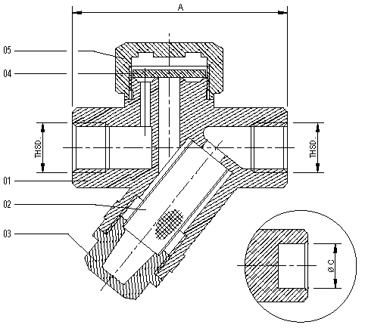

**Technical Data-**

* Screw End: ANSI B 2.1
* Socket weld End: ANSI B 16.11

**Use:**

|  |  |  |  |  |
| --- | --- | --- | --- | --- |
| Suitable For | | | | |
| Steam | Water | Oil | Air | Gases |
| * |  |  | * |  |

**Part Name:- Design Std:-**

|  |  |  |  |  |  |  |  |
| --- | --- | --- | --- | --- | --- | --- | --- |
| **No.** | **Part Name** | **Material** |  | **Size** | **A** | **Thread** | **C** |
| **01** | **Body** | **WCB / CF8 / CF8M** |  | **15** | **76** | **½” BSP / BSPT / NPT** | **21.7** |
| **02** | **Screen / Mesh** | **SS304** |  | **20** | **76** | **¾” BSP / BSPT / NPT** | **27.1** |
| **03** | **Plug** | **SS / SS304 / SS316** |  | **25** | **90** | **1” BSP / BSPT / NPT** | **33.8** |
| **04** | **Disc** | **SS / SS304 / SS316** |  |  |  |  |  |
| **05** | **Body Cover** | **WCB / CF8 / CF8M** |  |  |  |  |  |
|  |  |  |  |  |  |  |  |
|  |  |  |  |  |  |  |  |
|  |  |  |  |  |  |  |  |
|  |  |  |  |  |  |  |  |
|  |  |  |  |  |  |  |  |
|  |  |  |  |  |  |  |  |

**Due to continuous development Program, the design & data given in this leaflet are subject to change without prior notice.**

**ANITA ENGINEERING WORKS**



58-59, Narayan Estate, Opp. Shree Ram Estate, Nr. CMC Ltd. Odhav, Ahmedabad-382415, Gujarat, India

Phone: +91 79 22974101, Fax: +91 79 22875014

Email: eascovalves@gmail.com, eascovalves@yahoo.com, Web: [www.eascovalve.com](http://www.eascovalve.com)

